**Project progress report**

***Civil Engineering Challenges***

**Group 4**

Martin Pozdech – s2496712

Liz Hoffmann – s3353443

Ali Biabani – s3282791

Mehdi Khajavi – s3205290

11/10/2024

Table of Contents

Introduction 3

Existing knowledge 3

Area investigation 7

Counts 8

Planned measures 10

Next steps 11

Criteria assessment 11

References 13

# Introduction

This document will cover the progress on our project to encourage more people to use the F35 in Enschede. So far this includes the research we have done, our analysis of the area, count data we collected, and the interventions we believe would achieve our goal.

# Existing knowledge

Research Article 1: **Wayfinding for cycle highways: Assessing e-bike users' experiences with wayfinding along a cycle highway in the Netherlands (2020)**

The article (D. van Lierop, 2020), examines how improvements in wayfinding signage along a cycle highway between Tilburg and Waalwijk, Netherlands, impact e-bike users’ experiences. It evaluates both traditional and newly designed wayfinding systems ('Plus', and 'Snel'), focusing on factors like clarity, ease of navigation, and user perceptions. The study also aims to identify how adjustments to the design, placement, and visibility of signage can reduce travel-related stress and improve cyclists’ comfort. The findings indicate that the "Snel" system, characterized by its larger, arrow-shaped signs and high-contrast colors, significantly reduced navigational errors and travel-related stress.

**Methodology**:

The authors used a qualitative approach, including field observations, ride-along videos, and semi-structured interviews with e-bike users. The participants cycled a section of the F261 cycle highway, first with the original signage and then after the installation of two new pilot wayfinding systems ("Plus" and "Snel").

Key elements of the methodology:

* Participants: 12 e-bike users (6 younger, 6 older) unfamiliar with the route.
* Data collection: Observations were made during two periods (summer and fall of 2018), using video recording (GoPro and 360-degree cameras) and interviews after each cycle-along.
* Comparison of old vs. new wayfinding systems, including aspects like the size, height, and placement of signs, as well as ground markings.
* Metrics: The number of times cyclists hesitated or stopped to navigate, their stress levels, and perceptions of ease and comfort were recorded.

**Wayfinding Systems Characteristics**

Table 1: Wayfinding System characteristics

|  |  |  |  |
| --- | --- | --- | --- |
| **Feature** | **Original System** | **Plus System** | **Snel System** |
| **Sign Shape** | Rectangular | Rectangular | Arrow-shaped signs |
| **Color Scheme** | Red with white text | Red with white text | Red background, black text on white panels |
| **Height of Signs** | 2.25 meters (higher than eye level) | Eye-level for cyclists | Eye-level for cyclists |
| **Arrow Indicators** | Small arrows on the signage | Larger arrows for easier visibility | Sign itself shaped like an arrow |
| **Sign Placement** | At decision points (intersections) | At decision points, with pre-signs before turns | At decision points, pre-signs, and reassurance signs |
| **Ground Markings** | None | Specialty ground markings near decision points | Green lines for continuous navigation assistance |
| **Cycle Highway Logo** | None | None | Dedicated F261 logo and cycle highway number |
| **Font Size** | Standard-sized font for cycling signage | Larger font size for better readability | Larger font size with high contrast |
| **Signage Consistency** | Only at decision points | At decision points and regular intervals | Consistent repetition of logo and signage at intervals |

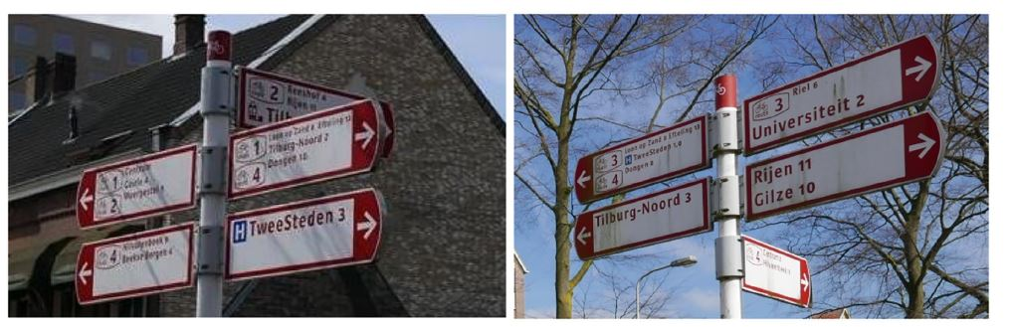

Figure 1: Original wayfinding signage for cyclists as experienced by participants in summer, 2018.

Table 2: Comparing concept Plus and concept Snel.

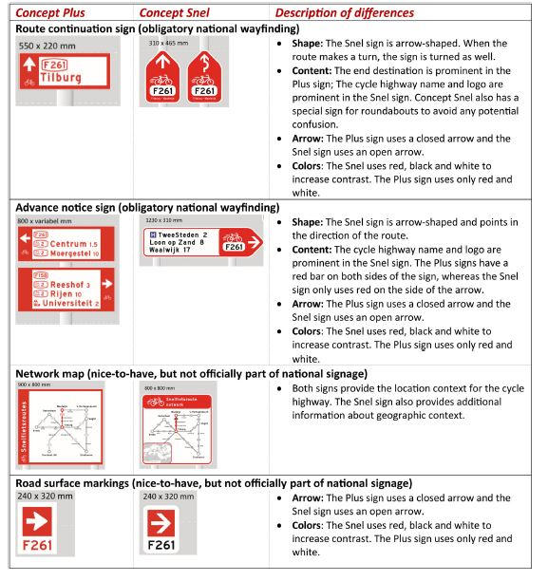

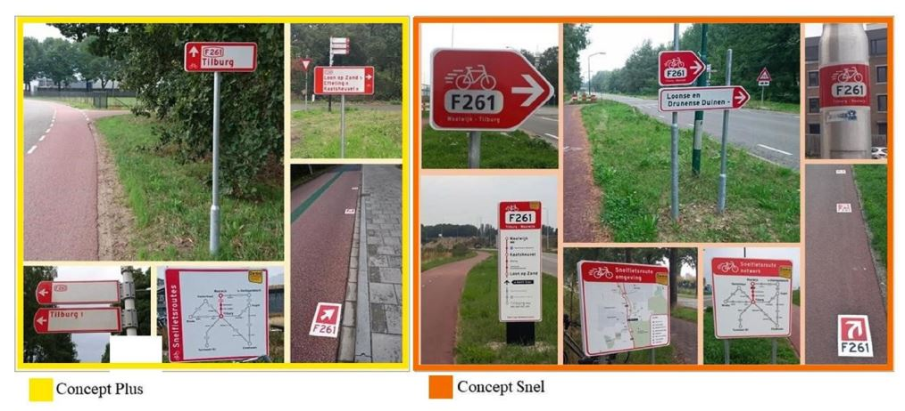

Figure 2: Concepts “Plus” and “Snel” as experienced by cyclists in fall, 2018.

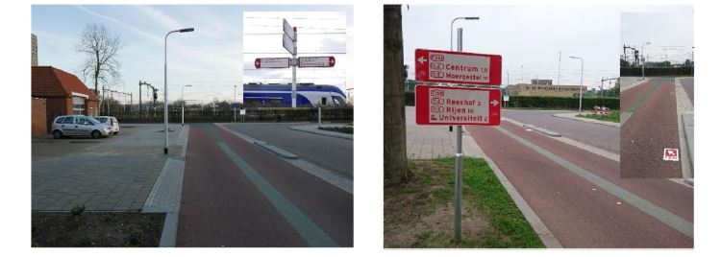

Figure 3: Before (left) and after (right) placing signs before an intersection

**Key Findings:**

**Improved Navigation**: The "Snel" system significantly reduced navigational errors. Participants made fewer stops or wrong turns, as indicated by a 79% reduction in navigation errors compared to the original signage (from 29 errors to 6 errors).

**Decreased Stress**: The clearer signage reduced cognitive load, leading to a more relaxed and enjoyable cycling experience. Some cyclists even perceived their travel time to be shorter due to fewer interruptions.

**Preference for "Snel"**: The distinct arrow-shaped signage, combined with high contrast (black text on white with a red background), allowed cyclists to interpret directions more quickly without slowing down.

**Impact on Perception**: The new signs gave cyclists more confidence in their route, improving their overall perception of the cycle highway. The consistent signage created a sense of continuity and reassurance.

Research Article 2: **Cycle Highway Effects: Assessing Modal Choice to Cycling in the Netherlands (2024)**

The article (Francisco Edson Macedo Filho, 2024), evaluates the impact of cycling highways on commuting behavior in the Netherlands. It focuses on whether these cycling highways have contributed to a shift from car use to cycling. The study gathers the data before and after the construction of the cycling highways to analyze commuting trips. To do this, the authors use the difference-in-differences methodology and data from the Dutch Travel Survey (2010–2021). The results show that introducing cycle highways increased the likelihood of cycling by 10%, particularly for trips traversing more than 5 km of the highway. The article's findings suggest that even in regions with extensive cycling infrastructure like the Netherlands, the construction of cycling highways can still drive significant modal shifts, particularly for longer-distance commutes.

# Area investigation

As with any transportation link, the F35’s usefulness depends greatly on its surrounding network. Looking at our project area, we find that the F35 does have a longer distance between the central station and the UT campus, with the F35 taking an extra 3-minutes and a little less than 1km. That does not however account for the waiting times at the 4 signalized intersections along the Hengelosestraat. Plus, cyclists can get up to higher speeds along the F35 due to its wide roads with no intersections—much like its namesake, the highway. That does come with drawbacks, however, with certain key areas lacking necessary offramps, such as on the Lambertus Buddestraat. Finally, the most useful offramps to get to the UT near Wkc. Twekkelerved are unpaved and not well signposted. It is very unlikely someone unfamiliar with the area would be able to find their way to the UT from here without guidance. That guidance is particularly lacking when Google Maps has failed since August to update their map to reflect the updates to the F35.

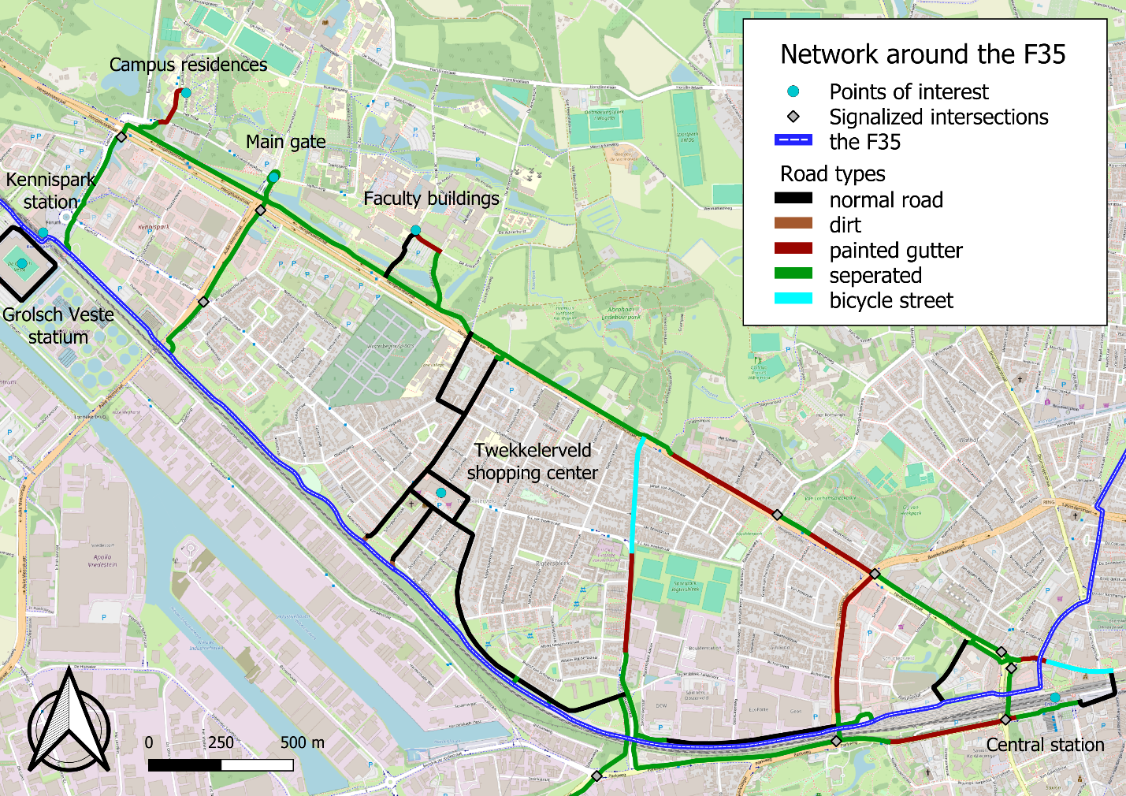

# Counts

Two bicycle counts were organized during rush hour in the morning to create a baseline, observe the current situation, and collect data on the F35's current usage. The first count was on 03.10.2024 from 08:00 to 09:00, and the second was on 10.10 at the same time. It was differentiated between normal bikes, electric bikes, and scooters.

It’s important to note that weather plays an important role in bike usage. It is assumed that on rainy days, the choice of using a bike for the daily commute will decrease. On the first count, the weather was dry and sunny. However, on the second count, it was cloudy and it started raining at around 08:30.

The exact spot where the counting happened was near the central station of Enschede at an on/off ramp of the F35 (at the red dot on the image below).

Bikes were counted heading from Enschede to Hengelo and vice versa.

First Count on 03.10.

|  |  |  |  |  |  |  |
| --- | --- | --- | --- | --- | --- | --- |
| Enschede to Hengelo | | | | | | |
|  | Normal | | Electric | | Scotter | |
| 8:00-8:10 | 23 | | 19 | | 2 | |
| 8:10-8:20 | 22 | | 16 | | 1 | |
| 8:20-8:30 | 27 | | 23 | | 4 | |
| 8:30-8:40 | 19 | | 13 | | 1 | |
| 8:40-8:50 | 27 | | 9 | | 0 | |
| 8:50-9:00 | 10 | | 9 | | 0 | |
| Total | 128 | | 89 | | 8 | |
| Summed up | 225 | | | | | |
| Hengelo to Enschede | | | | | | | |
|  | | Normal | | Electric | | Scotter | |
| 8:00-8:10 | | 6 | | 8 | | 1 | |
| 8:10-8:20 | | 12 | | 17 | | 2 | |
| 8:20-8:30 | | 11 | | 20 | | 2 | |
| 8:30-8:40 | | 6 | | 13 | | 4 | |
| 8:40-8:50 | | 6 | | 22 | | 1 | |
| 8:50-9:00 | | 4 | | 16 | | 2 | |
| Total | | 45 | | 96 | | 12 | |
| Summed up | | 153 | | | | | |

Second Count on 10.10

|  |  |  |  |
| --- | --- | --- | --- |
| Enschede to Hengelo | | | |
|  | Normal | Electric | Scooter |
| 8:00-8:20 | 51 | 23 | 7 |
| 8:20-8:40 | 43 | 8 | 3 |
| 8:40-9:00 | 35 | 12 | 2 |
| Total | 129 | 43 | 12 |
| Summed up | 184 | | |

|  |  |  |  |
| --- | --- | --- | --- |
| Hengelo to Enschede | | | |
|  | Normal | Electric | Scooter |
| 08:00-08:20 | 22 | 14 | 6 |
| 08:20-08:40 | 25 | 16 | 2 |
| 08:40-09:00 | 20 | 8 | 6 |
| Total | 67 | 38 | 14 |
| Summed up | 119 | | |

About 41 fewer bikes were counted coming from Hengelo to Enschede and 34 less coming from Enschede to Hengelo. This implies that the assumption about the weather could be right.

However, in order to properly analyse traffic data, several consecutive counts have to be executed on several days. Since only two counts could have been organized in such a tight timeframe, the collected data can be interpreted as rather vague. Nonetheless, the collected data serves as a good baseline, especially when noticing the differences in usage due to the weather.

# Planned measures

*“What could the municipality do to increase long-term the demand of bicycle traffic on the F35?”*

1. Plant trees/create windbreaks along the road
2. Improve off-ramp signage and road surfaces (near Twekkelerveld)
3. Add water fountains
4. Market (flyers) F35 to note how much safer it is thanks to being separated + less intersections

Table 3: Actions to be taken for F35

|  |  |
| --- | --- |
| **Location** | **Actions** |
| **Intersection near Enschede Station** | - Install red background signs with black text and large arrows at eye level 50-100 meters before turns.  - Add a continuous green line to guide cyclists through the station area and high-traffic zones. |
| **All Intersections** | - Install red background signs with black text and large arrows at eye level 50-100 meters before each intersection to inform cyclists of upcoming turns.  - Use clear, large directional arrows on both signs and the pavement to indicate the correct path at intersections.  - Add green lines or surface markings that lead cyclists smoothly through intersections, ensuring continuous guidance.  - Place small confirmation signs with the F35 logo immediately after turns to reassure cyclists they are still on the correct route.  - Install larger, more prominent signs at key junctions or confusing intersections to minimize hesitation or route deviations. |
| **Midway on F35** | - Place small, frequent reassurance signs with the F35 logo every 500 meters to confirm cyclists are on the correct path. |
| **At Kennispark** | - Install pre-signs with clear arrows and high-contrast colours to indicate directions to key landmarks (De Grolsch Veste Stadium, Twente University).  - Add green line or directional arrows on the pavement for additional guidance for exit specially for Twente University |
| **Key Decision Points (Intersections, Roundabouts)** | - Place pre-signage well before decision points (e.g., intersections, roundabouts) to give cyclists time to adjust and navigate smoothly. |

# Next steps

The next steps include meeting up with stakeholders such as Mobidot and the municipality of Enschede. The contact with Mobidot is in current development. A recent report about the F35 has been sent from a contact person of Mobidot in Dutch and has been analysed. It is used to develop a solution strategy and identify current key issues reported by users. Further NDA’s have been signed and sent for further intern data. The Mobidot data should serve as an analysis of who is (reported) to use the F35 and where those trips are coming and going. Based on that data and the given report as well as conducted research on the mentioned papers, a measure package on how to improve the F35 will be established and sent to a contact person of the municipality that is currently engaged in the F35. Therefore a short (1-page) proposal will be written to the municipality to discuss what they might see useful as well.

# Criteria assessment

|  |  |  |  |
| --- | --- | --- | --- |
| **Not Yet** (areas that need work) | **Proficient**  (performance standards) | **Evidence** (how you’ve met standards) | **Advanced** (areas that go beyond the basics) |
|  | **Big Idea and Challenge Selection**  Generates essential questions related to the Big Idea (sustainability/circularity) and from that identifies a creative, focused, and manageable Challenge (critical reflection on scoping, resources and feasibility) that addresses potentially significant, yet previously less-explored aspects of the Big Idea. | Our topic directly tackles a relevant issue that addresses sustainability. |  |
|  | **Design process**  All elements of the CBL methodology or other theoretical framework (approved by lecturer) are skillfully developed. Appropriate methodology or theoretical frameworks may be synthesized from across disciplines or from relevant subdisciplines (provided approval by the lecturer). | All the steps taken in each of the 3 phases of CBL (engage, investigate, act) are documented in the final report. From a big idea to forming essential questions focused on one chosen challenge, managing activities and research to investigate the current stage as well as presenting a solution to | Involving stakeholders, conducting feedback, increasing knowledge as well as achieving impact through the solution, show completeness of the CBL approach. |
|  | **Knowledge, Research, and/or views**  Regarding existing knowledge: gathers, investigates and synthesises in-depth information from relevant sources representing various points of view/approaches/perspectives to the Challenge. Regarding new knowledge and innovation: organizes and synthesizes evidence to reveal insightful patterns, differences, or similarities related to the Challenge. | Documents related to cyclist signposting are investigated. Road infrastructure and network design was looked at | Own data collection (counts) was performed. |
|  | **Data accessibility, storage and repository**  Information, knowledge and intermediate products are stored in a repository that meets Data Management and Privacy regulations. The repository is publicly available, or can be made available to individuals on request. | No personal data was used. Project data is stored in the cloud to reduce risk of loss. | Back ups have been done consistently |
|  | **Identify potential solutions**  Identifies multiple potential solutions for contributing to the Challenge that apply within a specific context. Solutions indicate a deep comprehension of the Challenge. Solutions are sensitive to contextual factors as well as all of the following: ethical, logical, and cultural dimensions of the Challenge. | A list of actionable interventions with which impact towards can be achieved is stated. |  |
|  | **Evaluate potential solutions**  Evaluation of solutions is deep and elegant (for example, contains thorough and insightful explanation) and includes, deeply and thoroughly, all of the following: considers history of previous solutions to the Challenge, reviews logic/reasoning, examines feasibility of solution, and weighs impacts of solution. |  |  |
|  | **Implement solution**  Implements the solution in a manner that addresses thoroughly and deeply multiple contextual factors of the Challenge. | Not at this stage yet |  |
|  | **Basic requirements**  Writing is clear, effective and insightful. Free of spelling or grammar mistakes. Transitions tie sections together, as well as adjacent paragraphs. Paragraphs are well structured and focused. Smooth flow and effective transitions within paragraphs. If tables and figures are used, they are explained and referred to in an appropriate way. The APA format for referencing is used accurately and consistently. All needed citations are included in the paper. The reference list matches the in-text citations, and are all encoded in APA format. The report includes a title page and informative headings and subheadings in all parts. It is indicated if and how AI (e.g. ChatGPT) is used. | Writing is clear. A title page is included. |  |
|  | **Pass/fail rules**  To pass this assignment, you need to score proficient on all performance standards. Areas that need work (left column) can be compensated with areas that go beyond the basics (right column). However, no more than 2 areas may be compensated. |  |  |

# References

D. van Lierop, J. S. (2020). Wayfinding for cycle highways: Assessing e-bike users' experiences with wayfinding along a cycle highway in the Netherlands. *Journal of Transport Geography*, Volume 88, ISSN 0966-6923,.

Francisco Edson Macedo Filho, H. P. (2024). Cycle highway effects: Assessing modal choice to cycling in the Netherlands. *Transportation Research Part A: Policy and Practice*, Volume 189, ISSN 0965-8564.